|  |  |
| --- | --- |
| Big Data and Machine Learning in Logistics | 2nd semester 2021 |
| Student number: 50211#90 | Student name: Nolwenn PIGEON 놀웬 피지언 |

**R Self-work submission**

Students are required to present outputs for each R commands

<Example>

Default dataset

> pairs (Default, col=Default$student)

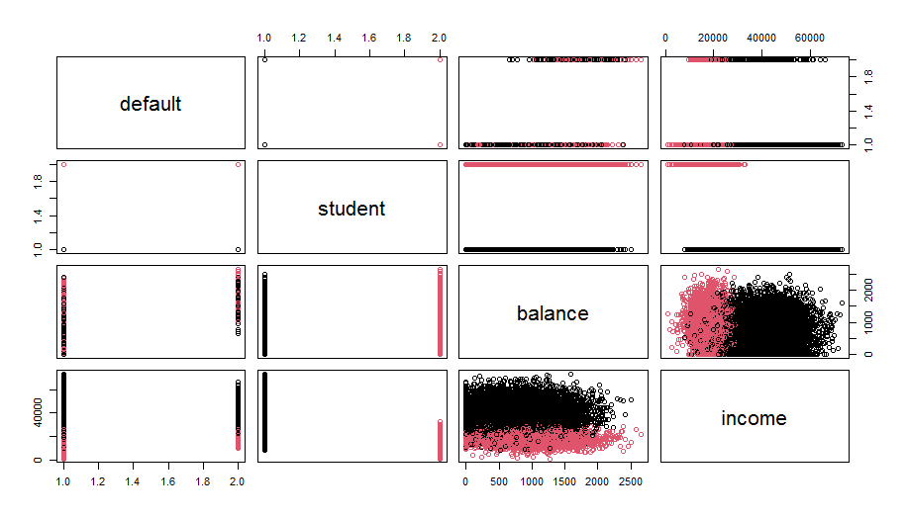

1. Auto dataset

> plot (cylinder, mpg, col=”red”)

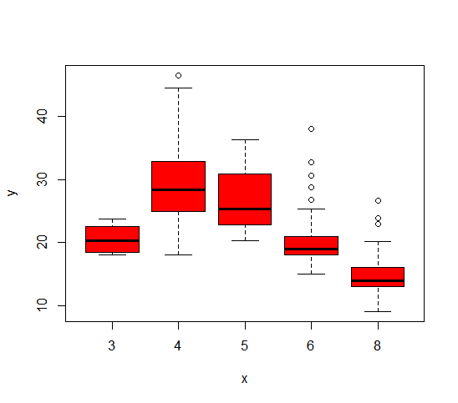

> hist (mpg, col=2)

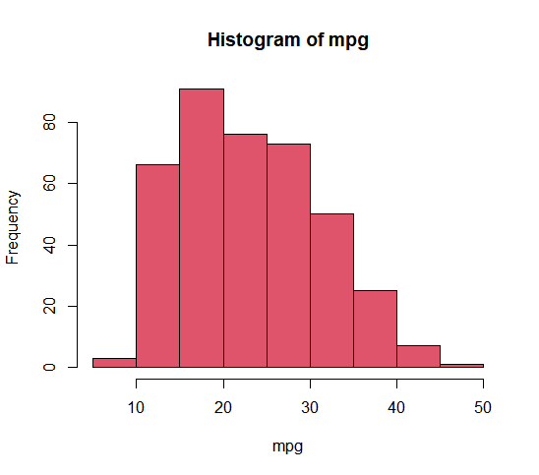

> pairs (Auto)

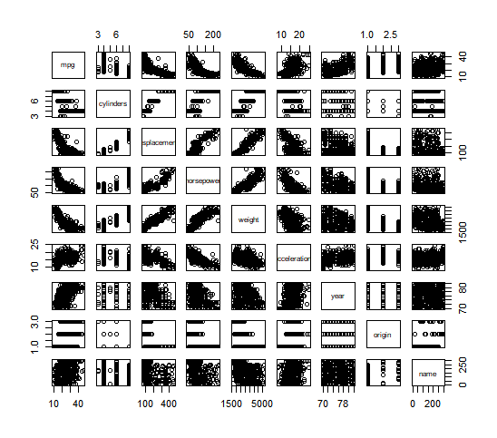

> summary (Auto)

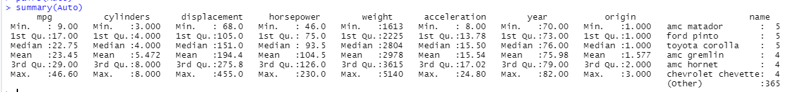

2. Boston dataset

> lm.fit=lm(medv~lstat)

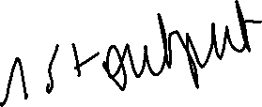

> summary(lm.fit)

> plot(lstat, medv)  
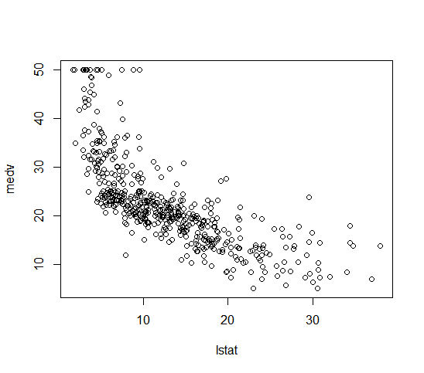

> abline(lm.fit)

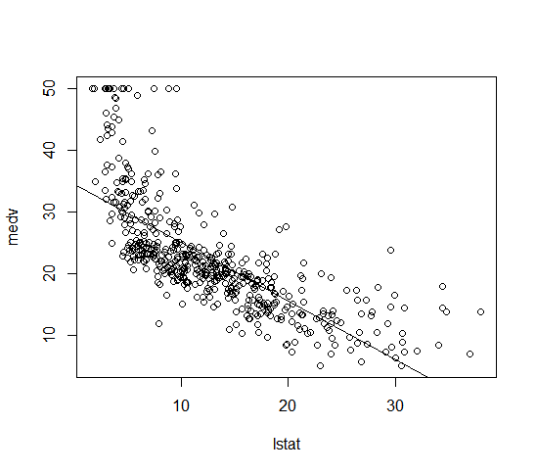

> lm.fit=lm(medv~lstat+age, data=Boston)

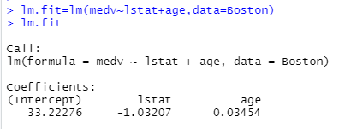

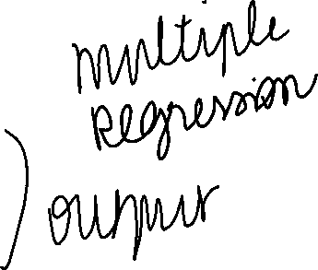

> summary (lm.fit)

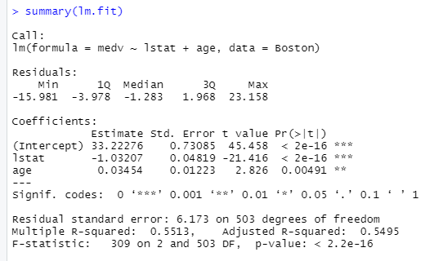

> lm.fit=lm(medv~. data=Boston)

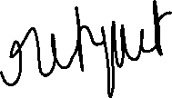

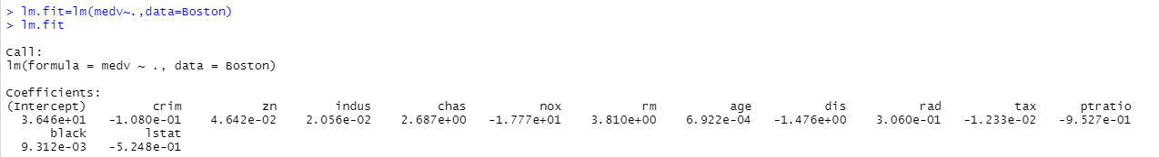



> summary (lm.fit)

